EchoCoach Stage 2 / Classes & History / Visual Concept v1.3 — REVIEW
01 · Classes landing
Original Classes landing screenshot (source page 1).
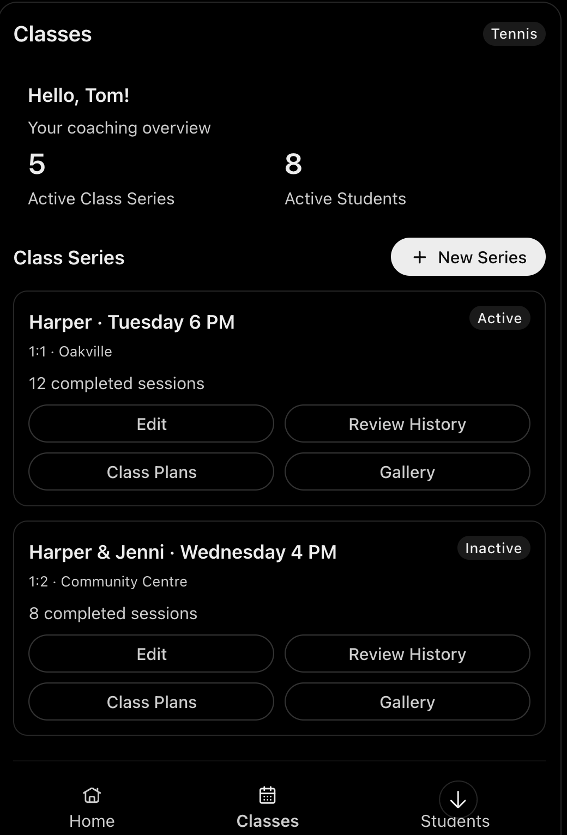 | WORKFLOW  Level 1 is Class Series. Greeting and coaching overview show active Class Series and active students. Series cards show student(s), ratio, location, completed-session count and active/inactive state.  ACTIONS  Four actions per series: Manage Class (replaces Edit in source screenshot), Review History, Class Plans, Gallery. Create New Series remains available.  DATA DOMAIN  Class Series identity = coach + sport + student set. Sport-scoped counts and cards; include inactive series in list but not active summary counts.
SOURCE: Embedded screenshot from user-supplied design files.docx • Screenshots retained unchanged; approved later decisions identified in commentary.

EchoCoach Stage 2 / Classes & History / Visual Concept v1.3 — REVIEW
02 · Create Class Series
Original creation form screenshot (source page 2).
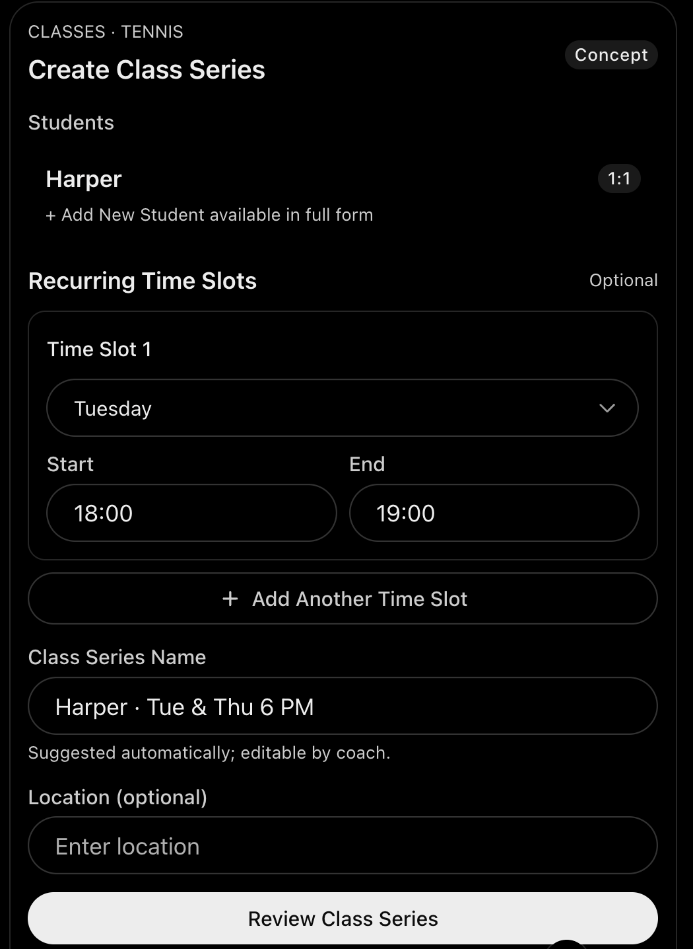 | WORKFLOW  Select student set, including + Add New Student; derive 1:1/group ratio. Define optional recurring slots, editable suggested series name and optional location. Review before save.  UPDATED DECISION  Each time slot has separate day, start time and end time inputs, plus independent every 1–4 week recurrence and first-occurrence anchor date. See next board for original recurrence design.  DATA DOMAIN  Student set locks after creation; editing schedule, name or location does not create a new series. Prevent duplicate coach + sport + student-set combinations.
SOURCE: Embedded screenshot from user-supplied design files.docx • Screenshots retained unchanged; approved later decisions identified in commentary.

EchoCoach Stage 2 / Classes & History / Visual Concept v1.3 — REVIEW
03 · Recurring schedule
Original recurrence detail screenshot (source page 3).
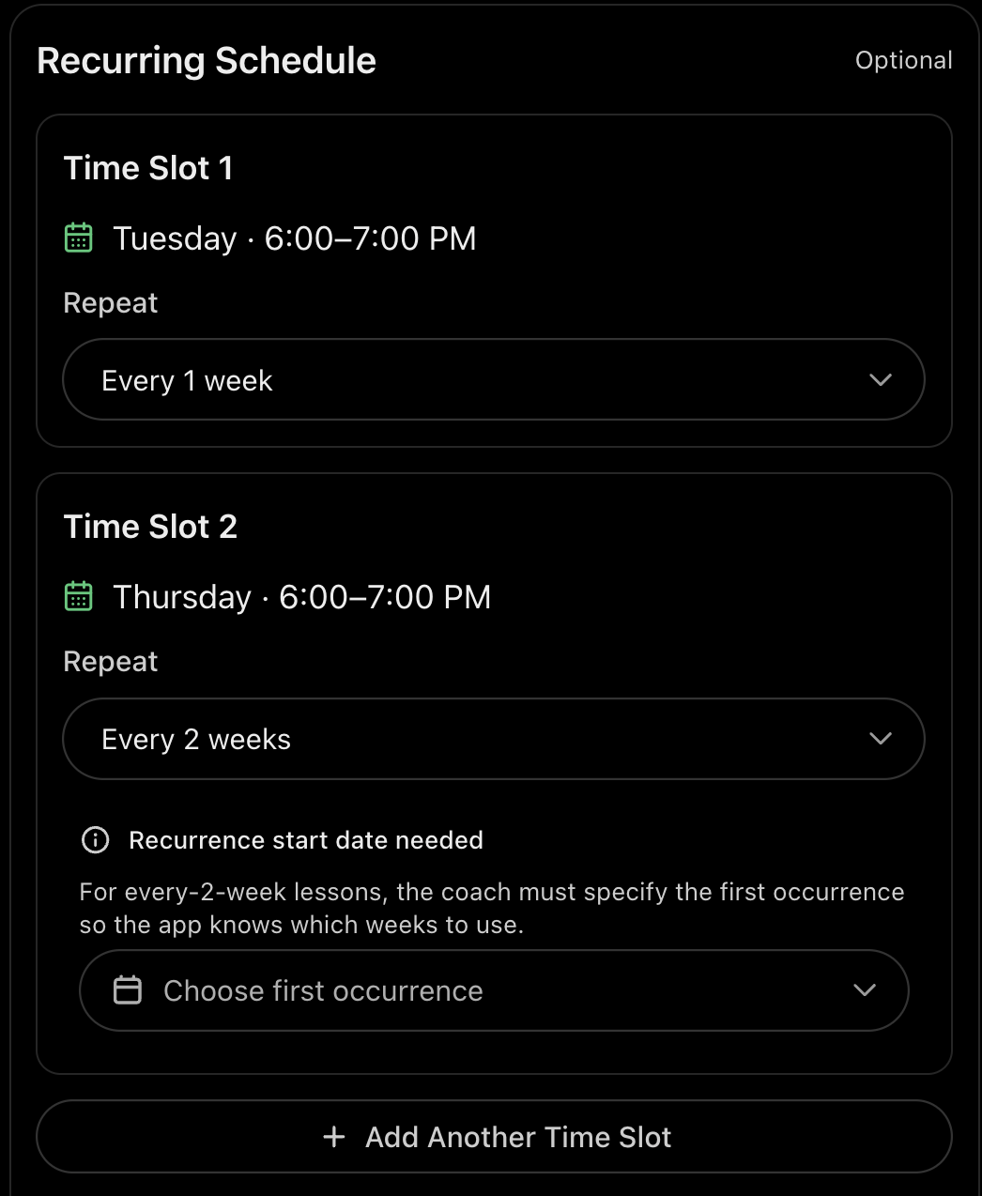 | WORKFLOW  Each time slot supports day/time, repeat every 1, 2, 3 or 4 weeks and first occurrence. Multiple slots per Class Series; add/remove slots.  UPDATED DECISION  Use a first-occurrence anchor date for each slot, including weekly slots, as agreed in the later interactive design. Keep separate start/end time fields from the creation screen.  DATA DOMAIN  Recurrence is configuration on Class Series, not a Class Session generator. Existing sessions stay unchanged after schedule edits; suggest dates only.
SOURCE: Embedded screenshot from user-supplied design files.docx • Screenshots retained unchanged; approved later decisions identified in commentary.

EchoCoach Stage 2 / Classes & History / Visual Concept v1.3 — REVIEW
04 · Master Review History
Original interactive history screenshot (source page 4).
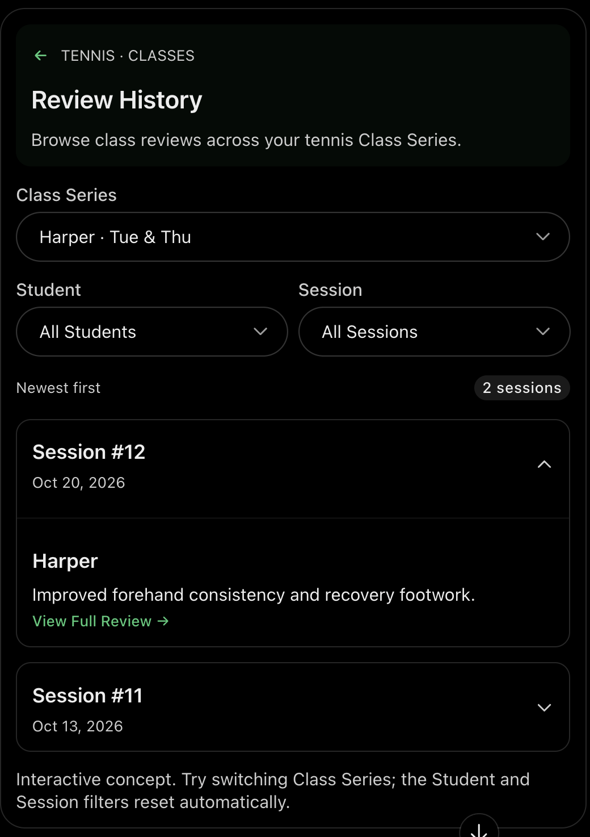 | WORKFLOW  Sport-scoped filters: Class Series → Student → Session. Entry context preselects filters. Individual student review cards, newest first, show review summary and View Full Review.  UPDATED DECISION  Use two most recent review cards by default, then Load More two at a time. Add secondary New Class Review action. The source screenshot groups visually by Session; approved final rule is individual student review cards, not session-group cards.  DATA DOMAIN  One Class Review per student per session. Exclude sessions without reviews; absent students have attendance but no invented review. Linked plan available when present.
SOURCE: Embedded screenshot from user-supplied design files.docx • Screenshots retained unchanged; approved later decisions identified in commentary.

EchoCoach Stage 2 / Classes & History / Visual Concept v1.3 — REVIEW
05 · Review History interaction rules
Original six-rule screenshot (source page 5, top).
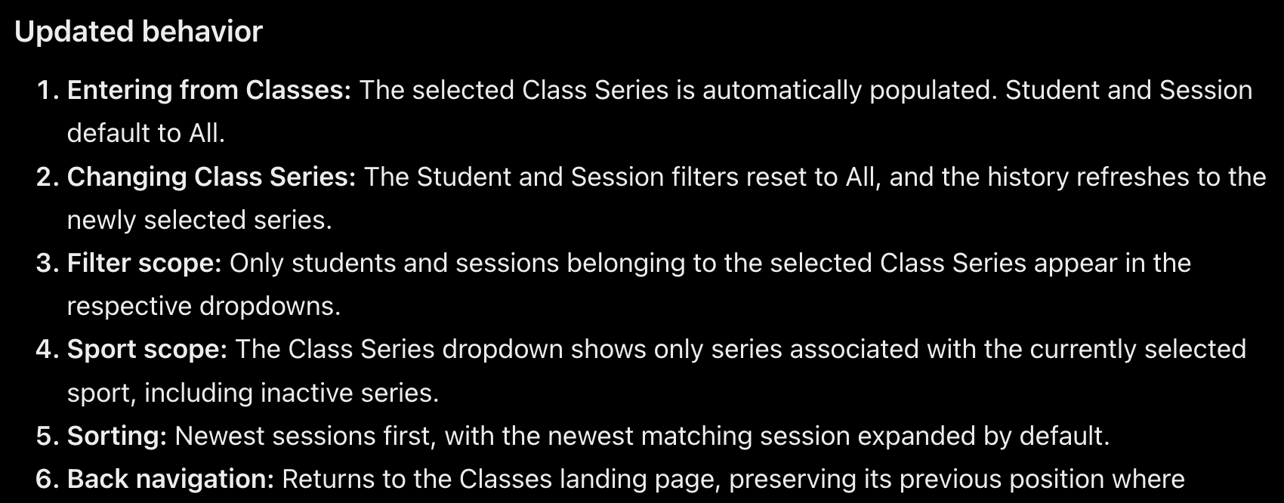 | WORKFLOW  Series prefilled from Classes; Student and Session default to All. Changing series resets dependent filters. Limit filters to current series and active sport; preserve back-navigation context.  UPDATED DECISION  The screenshot describes expanding the newest session by default; final approved display uses individual review cards. Keep navigation/filter rules but not session-accordion grouping.  DATA DOMAIN  Series selection includes inactive series for history; historical reviews remain accessible.
SOURCE: Embedded screenshot from user-supplied design files.docx • Screenshots retained unchanged; approved later decisions identified in commentary.

EchoCoach Stage 2 / Classes & History / Visual Concept v1.3 — REVIEW
06 · Master Class Plan Archive
Original archive screenshot (source page 5, bottom).
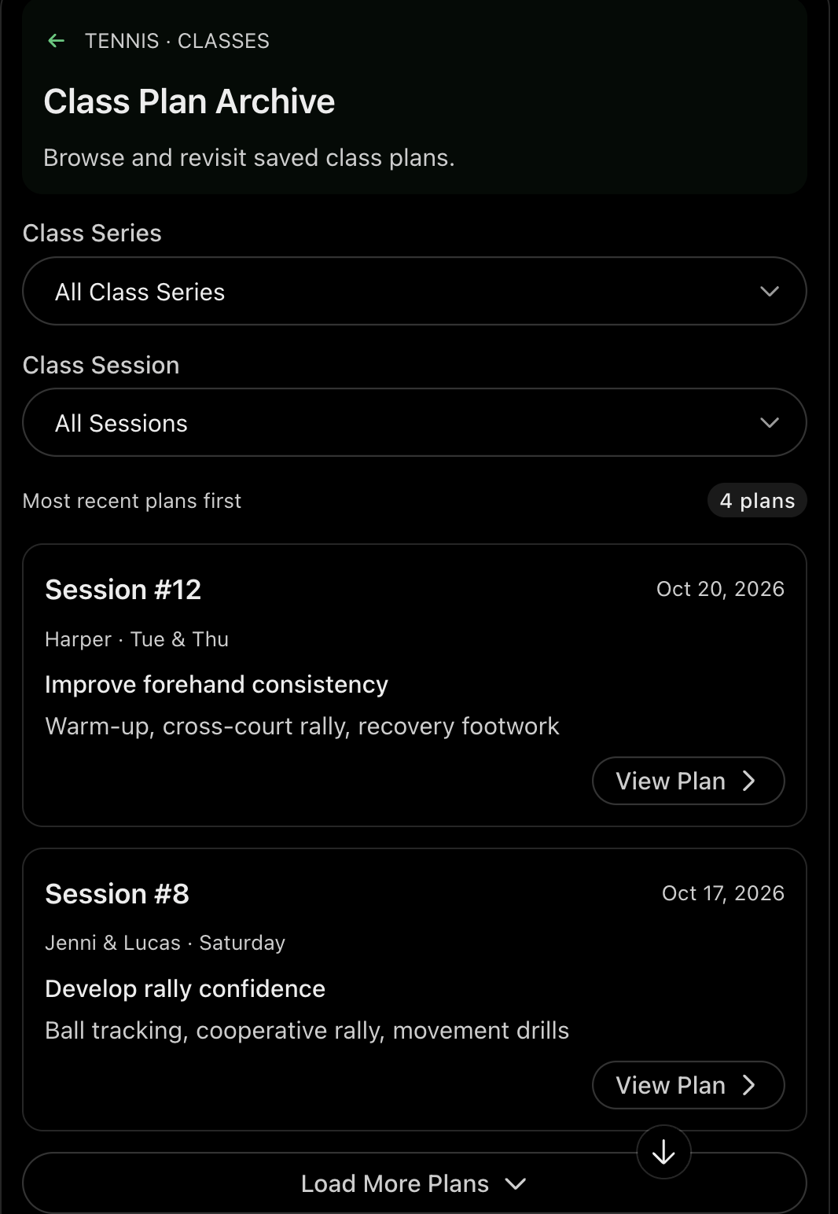 | WORKFLOW  Filters: Class Series and Class Session only (no Student filter). Plan cards show series, session, date, class goal, agenda preview and View Plan.  UPDATED DECISION  Show two most recent plans by default; Load More two at a time. Add New Class Plan secondary action. Include plans for upcoming and completed sessions.  DATA DOMAIN  One Class Plan per Class Session; no student ownership. Exclude sessions without a plan. Distinguish plannedDate from confirmed sessionDate.
SOURCE: Embedded screenshot from user-supplied design files.docx • Screenshots retained unchanged; approved later decisions identified in commentary.

EchoCoach Stage 2 / Classes & History / Visual Concept v1.3 — REVIEW
07 · Master Gallery
Original Gallery screenshot (source page 6).
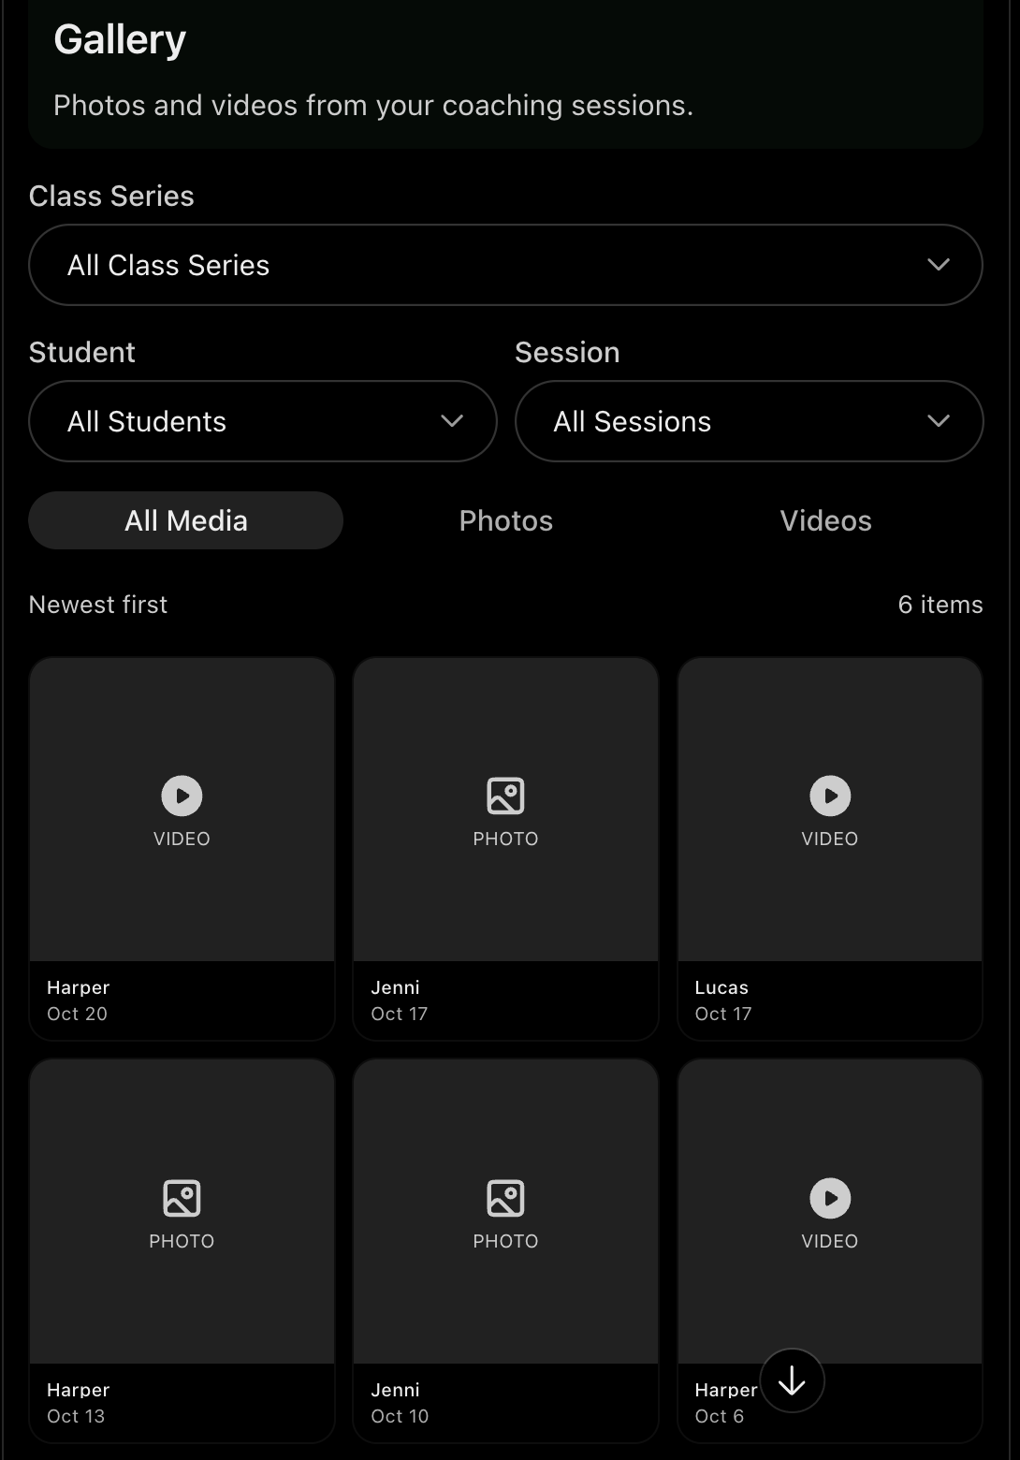 | WORKFLOW  Filters: Class Series, Student, Session, and All Media / Photos / Videos. Newest-first thumbnail grid, open full-screen viewer; progressive loading.  UPDATED DECISION  Support Upload Media from Gallery, Class Review and Class Session context. Student filter shows tagged media; untagged session media appears in All Students or session context.  DATA DOMAIN  Each media item belongs to one Class Session and may tag zero, one or multiple students without duplicating the file. Detailed storage/delete behavior belongs to Media workflow.
SOURCE: Embedded screenshot from user-supplied design files.docx • Screenshots retained unchanged; approved later decisions identified in commentary.

EchoCoach Stage 2 / Classes & History / Visual Concept v1.3 — REVIEW
08 · Manage Class — Sessions tab
Original lightweight Sessions tab screenshot (source page 7).
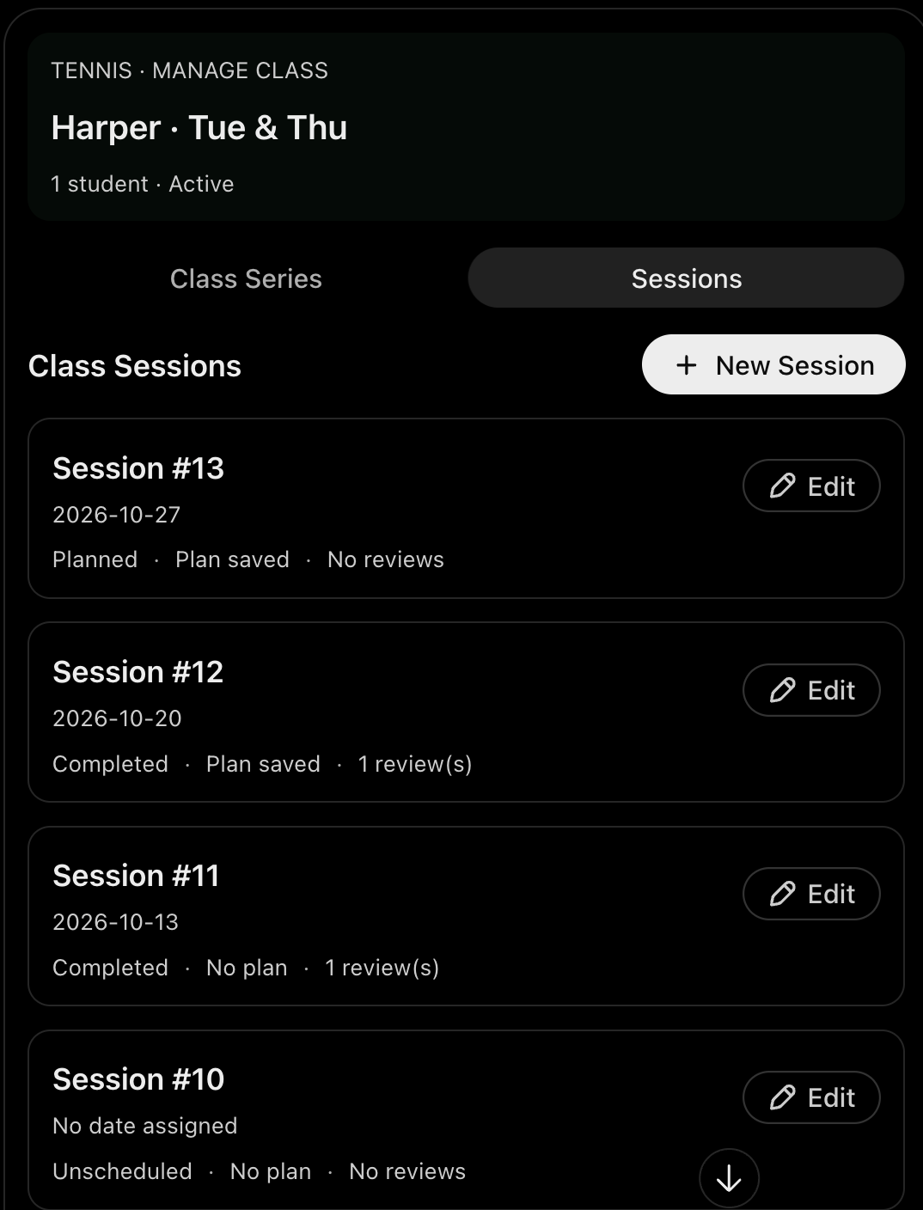 | WORKFLOW  Manage Class has two tabs: Class Series and Sessions. Sessions list shows sequence, date, inline Planned/Completed/Unscheduled, Plan saved/No plan, review count, Edit and New Session. No status filters or accordions.  EDIT / DELETE  Edit plannedDate or confirmed actual sessionDate; confirm deletion. Only empty sessions without plan, reviews, attendance or media are eligible for deletion.  DATA DOMAIN  Creation-order session numbering; date changes do not reorder. Deletion renumbers subsequent sessions, while stable internal IDs and associations persist. Corrected sessionDate propagates to linked records.
SOURCE: Embedded screenshot from user-supplied design files.docx • Screenshots retained unchanged; approved later decisions identified in commentary.

